- Establishment of building at Institute of Animal Nutrition, Kattupakkam to house the TANUVAS GRAND production plant.
Floor plan was prepared as follows
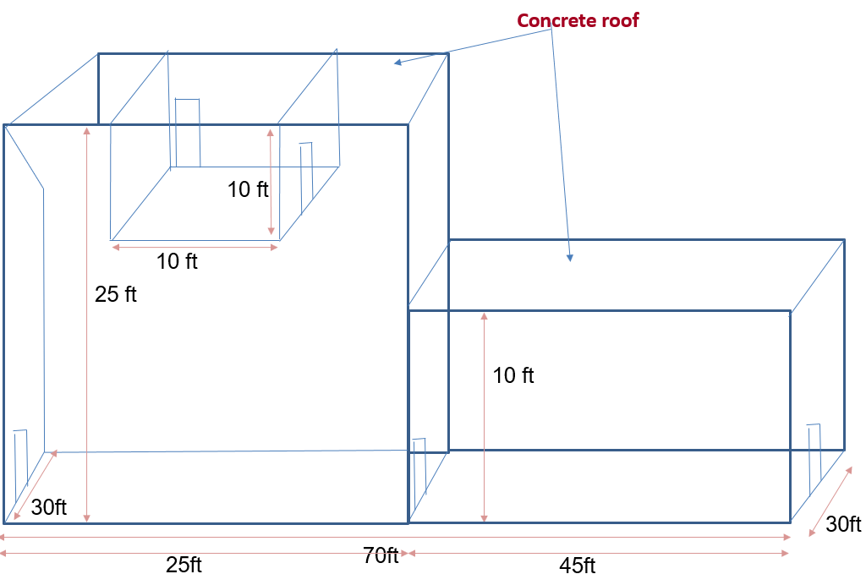
Location of the plant is near to IAN main building
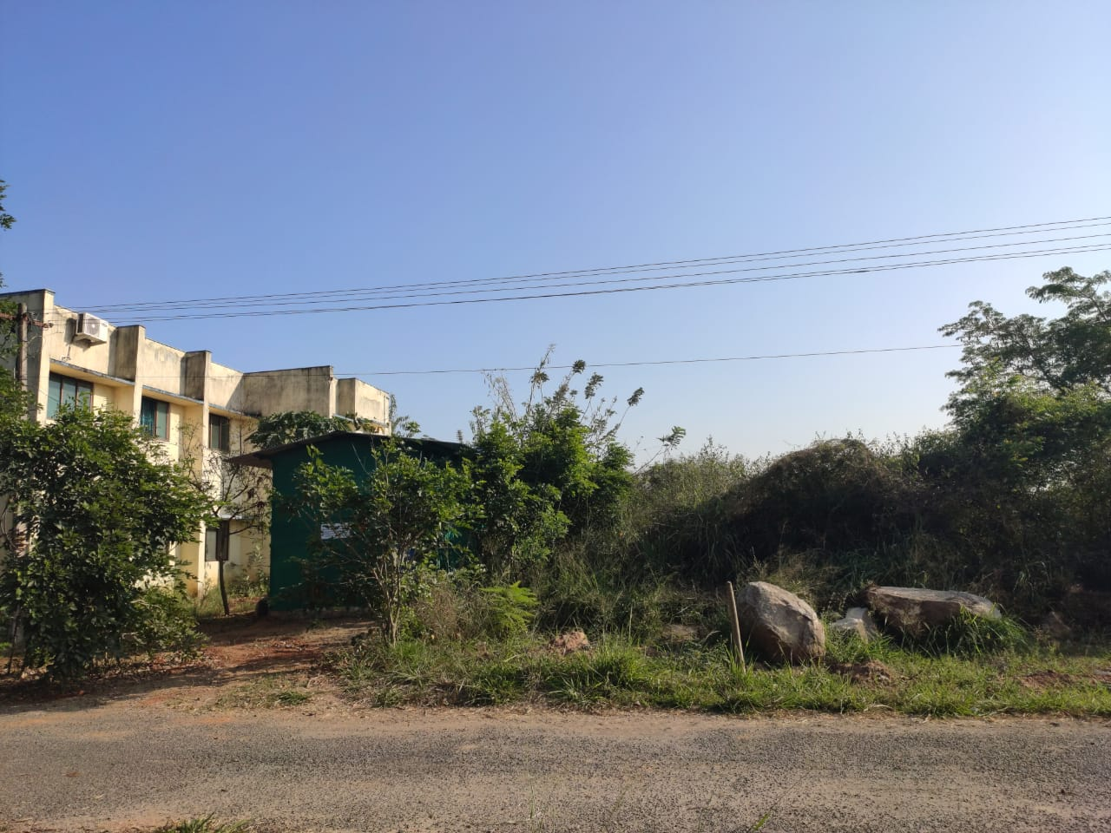
- A TANUVAS GRAND production plant with the capacity of 15,000 litres (25,000 bottles @ 600 ml/bottle) per day will be established at Institute of Animal Nutrition, Kattupakkam.
Plan and specification of plant were prepared as follows



